

User Guide

Dynamics CRM Upgrade Assessment Tool

Microsoft Internal

**Prepared by**

Narendra Magare

**Contributors**

Contents

Revision Sheet 4

What’s New 5

Prerequisite 5

How to Use 5

Source CRM 4.0 5

CRM Versions 6

Configuration Files 7

Upgrade Path 8

Customization Footprint 9

From 2011 11

What to Expect 15

Assessment Reports 15

AutoGenerated_FitGapAnalysis.xlsx 15

CustomerDetails 15

Summary 15

ComponentAggregates 16

ComponentAggregatesBySolution, 16

EntityTransaction, 16

JScript 16

Plugins 16

Workflows 16

CustomApplications 17

KB_DotNetCode 17

KB_JScript 17

Sitemap 17

ISV 17

Plugins Steps 17

Reports 17

DB_EntityTransactionDetails 17

DB_POA 17

DB_Size 17

DB_MaxRecordInfo 17

Info_Workflows 17

Info_UserAggregate 17

Info_User 17

Info_Roles 17

Info_Relationships_Connections 17

Info_Entities 17

AutoGenerated_UpgradeAssessment.docx 18

AutoGenerated_UpgradeAssessment.pdf 18

Configure Tool 19

SheetSequence 19

FileExclusionList 19

ClientSideMappings.xml 19

ServerSideCodeMappings.xml 19

DB Assessment Tool 20

How to use 20

Appendix 21

Keyword Category 21

# Revision Sheet

Contributors

|  |  |
| --- | --- |
| Name | Position |
| Narendra Magare | Initial draft |
|  |  |

# What’s New

In this new release of the tool, improvements around generating accurate numbers for client side and server side code are added. Client side assessment is improved by adding pattern matching while parsing the file. For Server side code assessment, Roslyn (The .NET Compiler Platform ("Roslyn") provides open-source C# and Visual Basic compilers with rich code analysis APIs.) is been leveraged. For more information about Roslyn, visit <https://github.com/dotnet/roslyn>

# Prerequisite

To run this tool, you do not need to have active CRM instance. This is standalone WPF application and .net framework 4.5 should be installed.

# How to Use

The tool can assess below objects for given CRM project:

1. CS files with associated Visual studio project/solution
2. CRM Customization/Plugin registration xml files (in case of CRM 4)
3. CRM Solution files

The tool is mostly a wizard like flow to get inputs from user, and the input is mostly same for various source CRM versions except CRM 4 as source version, in case CRM 4 as source CRM version, the inputs are different and tool asks for additional inputs such as customization.xml, plugin registration.xml file path etc.

CRM 2011 onwards, it needs folder path where CRM solution (.zip) file is located. Tool supports assessment for multiple solution files but all solution files have to be in same folder. The tool expects unmanaged solution files.

In case of server side code assessment, tool expects complete Visual studio projects or solutions. Current version of tool supports only C# project files(.csproj).

For complete assessment of CRM implementation, it is not necessary to provide solution files and related source code files always, if you want to assess only client side objects, you can leave ‘Server side code’ field blank and specify solution and related inputs. And if you want to assess only server side code, you need to specify ‘server side code’ field value and keep other fields blank.

Below sections describe how you can use the tool to assess upgrades from CRM 4 and CRM 2011.

## How to Get Started

d only for reporting purposes.

### Client Side

If you are evaluating Client Side requirements, start off by creating a solution with all of your organizations web resource files. As you select them, make sure you only select unmanaged files. Once selected, export the solution for later use by the tool.

## Source CRM 4.0

If you are assessing CRM 4 implementation, you can specify below inputs to the tool. Customer details specified here are used only for reporting purposes.

### CRM Versions

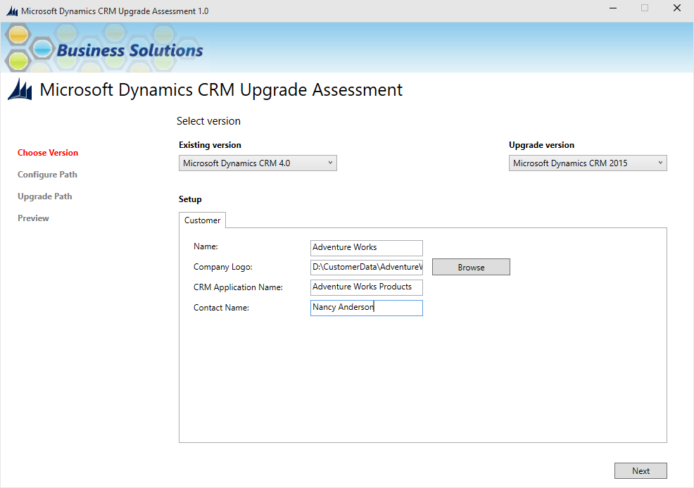

Figure 1 – CRM Versions

#### Fields on the screen

|  |  |  |  |
| --- | --- | --- | --- |
| No | Field | Description | Requirement |
| 1 | Existing version | This is list of source (current) CRM version | Required |
| 2 | Upgrade version | List of CRM versions to which you want to upgrade | Required |
| 3 | Name | Name of customer | Optional |
| 4 | Company Logo | Customer company logo image file | Optional |
| 5 | CRM Application Name | Customers CRM application name being assed | Optional |
| 6 | Contact Name | Name of contact person from customer side | Optional |

Table 1

### Configuration Files

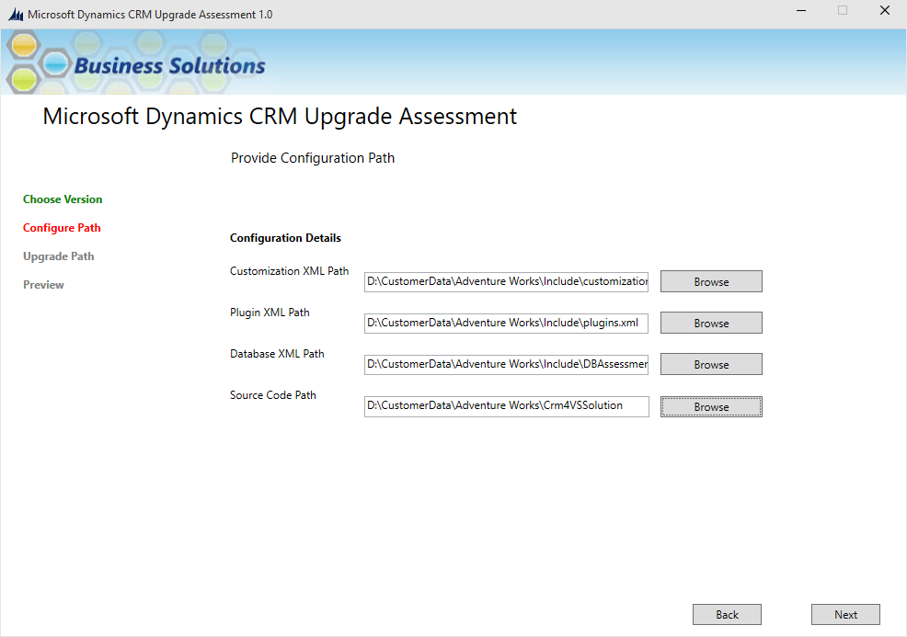

Figure 2 – Configuration Files

Fields on the Screen

|  |  |  |  |
| --- | --- | --- | --- |
| No | Field | Description | Requirement |
| 1 | Customization XML Path | Full customization.xml file path (in case of CRM 4 as source) | Optional |
| 2 | Plugin XML Path | Plugin registration xml file path | Optional |
| 3 | Database XML Path | Full path of ‘DBAssessmentReport.xml’ file, this file is generated by DB Assessment tool | Optional |
| 4 | Source Code Path | Path of directory which contains server side code of given CRM implementation | Optional |

Table 2

## Upgrade Path

This screen shows possible upgrade path to be followed for the upgrade.

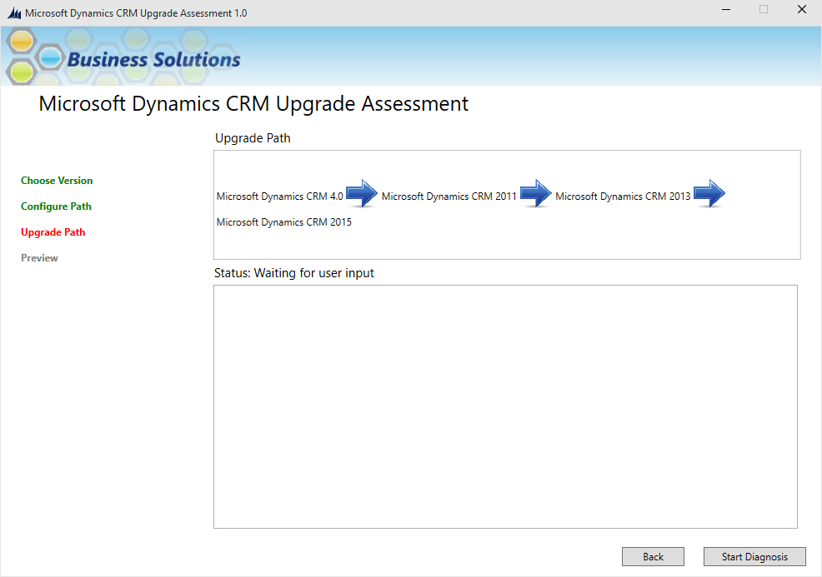

Figure 3 – Upgrade Path

Next tool shows a confirmation message to user.

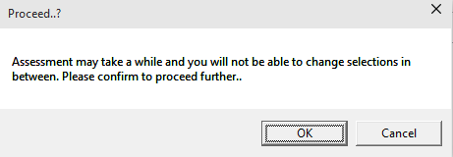

Figure 4 – Confirmation Message

After successful run, the tool displays summary of the objects it assessed.

### Customization Footprint

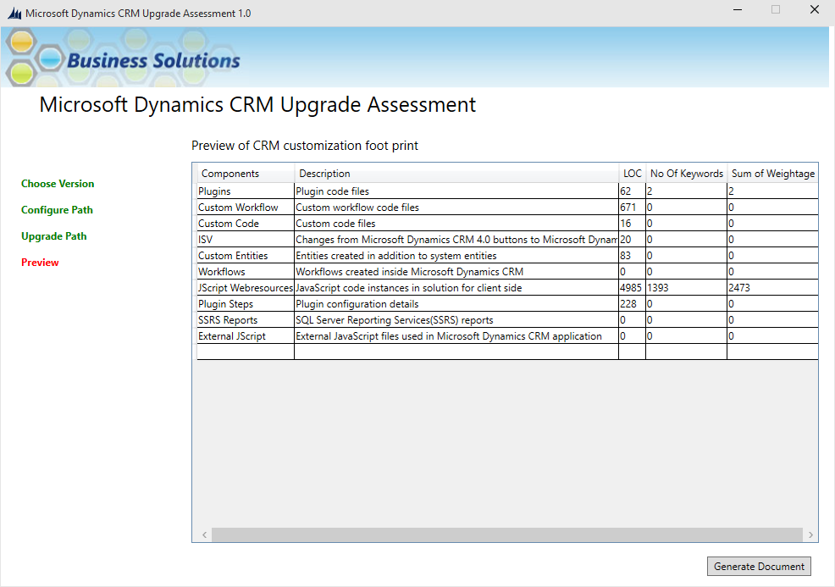

Figure 5 – Customization Footprint

1. Click on ‘Generate Document’ button to generate Assessment reports.   
   While generating reports tool creates a folder with name as current timestamp (sample folder name could be ‘20150408_135759’) tool stores documents generated inside this folder. It also creates operation log file with name as ‘AssessmentTrace_<timestamp>.log’.  
   The below image shows sample list of documents that are created.

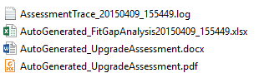

Figure 6 – Sample List of Documents

And it automatically opens the excel file after all documents are created.

The assessment is completed and you can click the Close button on next screen to close the tool.

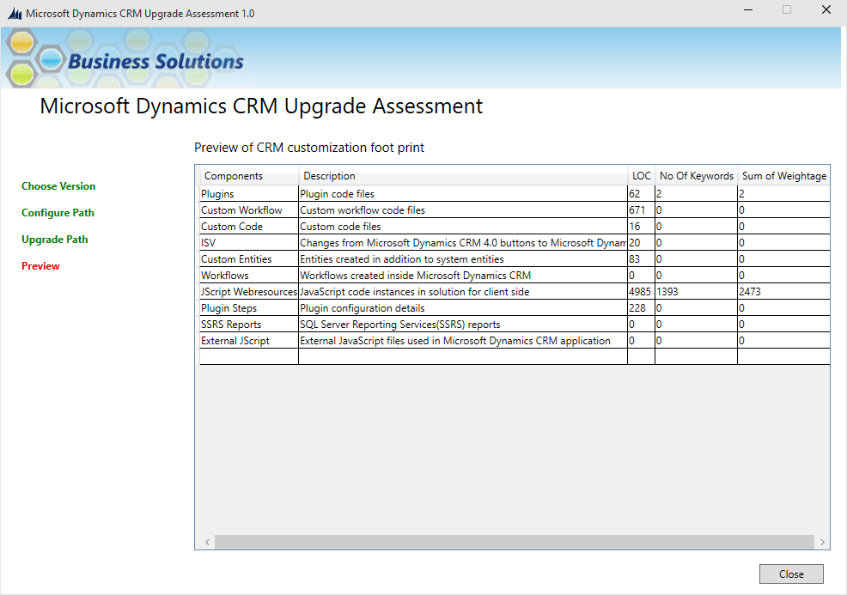

Below are sample dashboards added to report file.

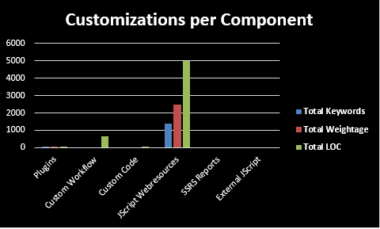

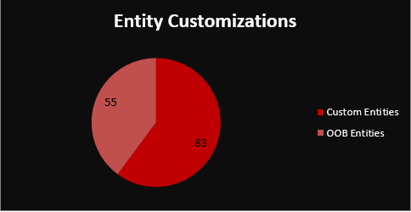

## From 2011

To assess from CRM 2011 select existing version as ‘Microsoft Dynamics CRM 2011’ and fill appropriate customer details.

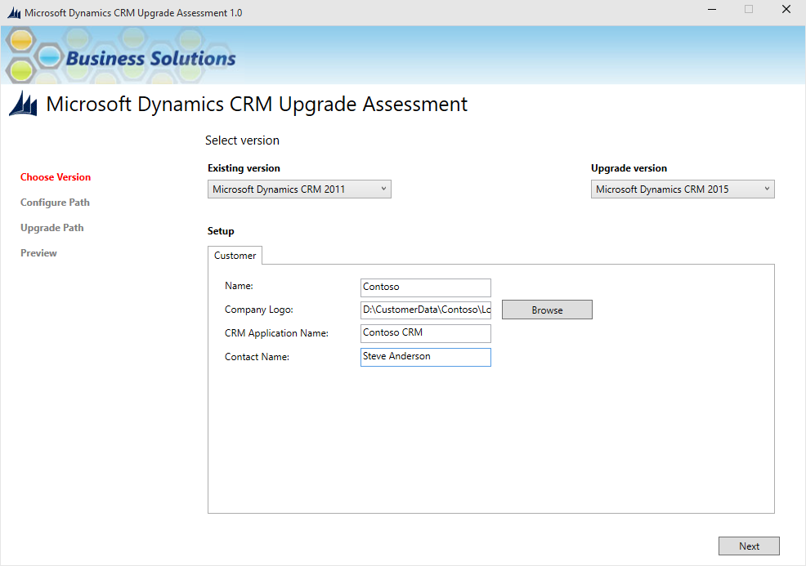

Figure 7 CRM version

On next screen specify solution file path other fields

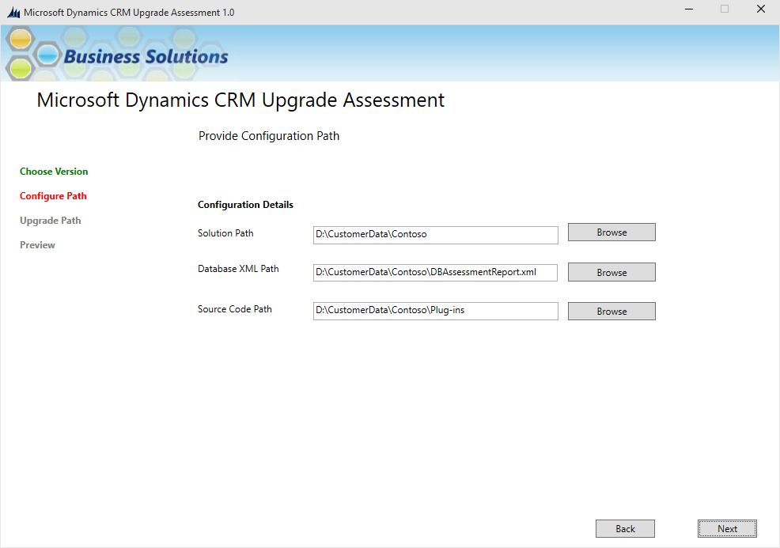

Figure 8 Configuration path

Fields on the Screen

|  |  |  |  |
| --- | --- | --- | --- |
| No | Field | Description | Requirement |
| 1 | Solution Path | Location of CRM solution zip file/s | Optional |
| 2 | Database XML Path | Full path of ‘DBAssessmentReport.xml’ file, this file is generated by DB Assessment tool | Optional |
| 3 | Source Code Path | Path of directory which contains server side code of given CRM implementation | Optional |

Table 3

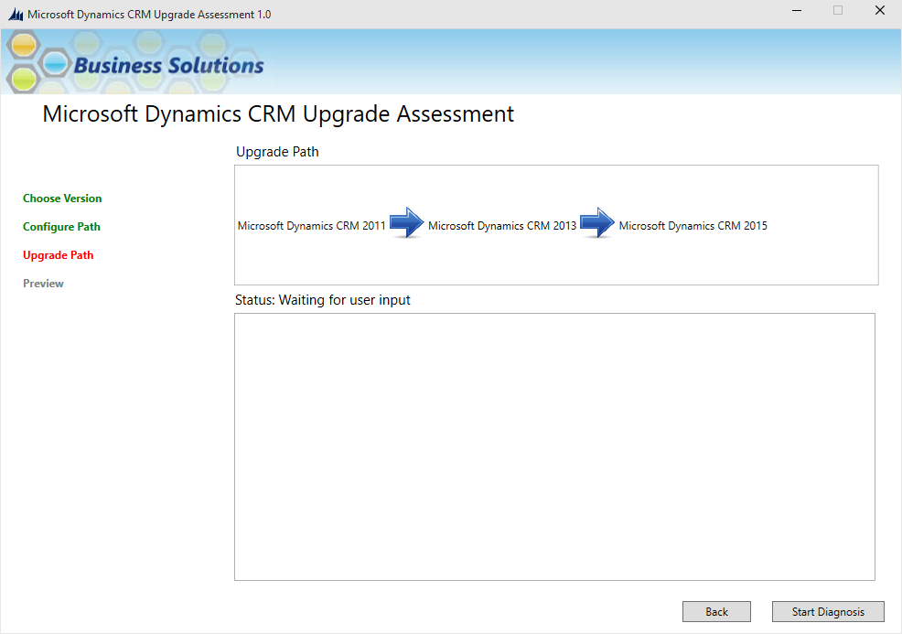

Figure 9 Upgrade path

Click on Confirmation message shown.



Figure 10 Confirmation message

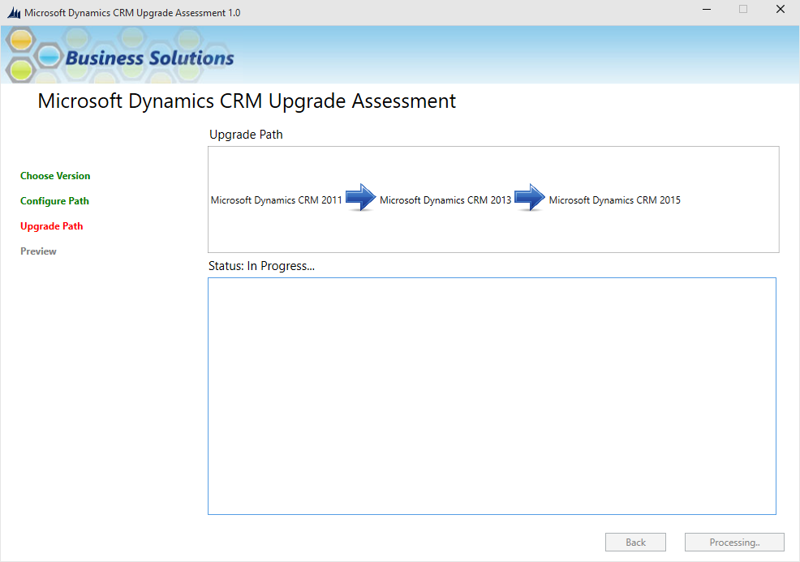

Figure 11 Operation in progress

After completion summary will be shown as below

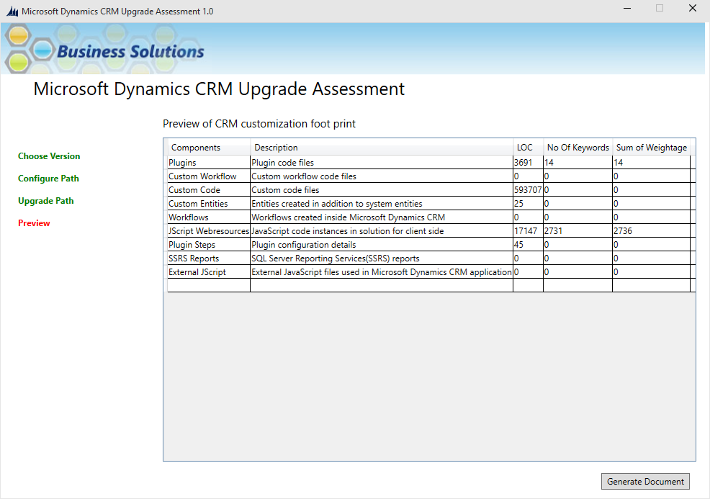

Figure 12 Summary

Click ‘Generate Document’ if you want to generate assessment reports.

## What to Expect

The tool reads all files from given solution (customization file and client side) and visual studio solution and assess them to migrate at given CRM version. Tool writes its results in the output assessment report files listed below.

1. AutoGenerated_FitGapAnalysis<Timestamp>.xlsx
2. AutoGenerated_UpgradeAssessment.docx
3. AutoGenerated_UpgradeAssessment.pdf

# Assessment Reports

The tool generates three files as assessment report, shown in Figure 10 – Sample List of Documents. Details about each document as below

## AutoGenerated_FitGapAnalysis.xlsx

This excel file gives detailed analysis of assessment, it contains sheets listed below

### CustomerDetails

This sheet shows customer details, these are same as input given in first screen. This sheet will be blank if there is no information provided in first screen (refer Figure 11 – CRM Versions)

### Summary

This sheets shows assessment summary as pivot tables and charts.

#### User per Role

This chart shows no of users present in each role shown. This chart will be blank if you haven’t provided ‘DBAssessmentReport.xml’ file to the tool. This file is generated by another tool called DB assessment tool.

#### Customizations per Component

This sheet shows amount of customization done using plugins, Custom workflow Custom Code etc. Amount of customizations is given in terms of Total Keywords, Total Weightage and Total LOC (lines of code). More about these is given in next few sections.

#### Entity Customizations

This chart shows no of Out of the box entities used and number of custom entities created

#### Last three month entity usage

This chart shows information about entities used in last three months

### ComponentAggregates

This sheet shows assessment by CRM component such as Plugins, Custom Workflow etc.

### ComponentAggregatesBySolution,

If multiple CRM solutions are provided to the tool this sheet will show assessment summary by each CRM solution.

### EntityTransaction,

This sheets shows entity transactions (records created or updated in CRM) in last three months.

### JScript

This sheet shows detailed assessment for JScript web resources found in CRM Solutions. Details such as no of lines of code, control and control event on which particular part of the code is called. Occurrence of each keyword in the file and final calculated weighted average. Weighted average is calculated as below

Weighted Average=Sum (A1+A2……+An)

Where A=Keyword 1 occurrence * Weightage

Here Weightage for each keyword is specified in config file ‘ClientSideMappings.xml’

### Plugins

This sheet shows assessment for plugin code, it shows Visual studio solution and project name in which the plugin file is present, full file path, Name of the file, file category it will be always Plugin (in case of plugin files), Lines of code and Weighted average for the file and occurrence of each keyword found in the file. Weighted average is calculated as below

File Weighted Average=Sum (A1+A2……+An)

Where A=Keyword 1 occurrence * Weightage

Here Weightage for each keyword is specified in config file ‘ServerSideCodeMappings.xml’

### Workflows

This sheet shows assessment for workflow code, details and calculations are same as plugins.

### CustomApplications

This sheet shows assessment for code which is not identified as Plugin or Workflow, details and calculations are same as plugins.

### KB_DotNetCode

This sheet shows keywords found in server side code and its Weight specified in config file, recommended replacement keyword and Category (for detail refer appendix)

### KB_JScript

This sheet shows keywords found in client side code and its Weight specified in config file, recommended replacement keyword and Category (for detail refer appendix)

### Sitemap

This sheet shows sitemap customizations done in source CRM application

### ISV

In case of CRM 4 this sheet shows changes made to ISV

### Plugins Steps

This sheets shows details about plugin registration steps.

### Reports

All the SSRS reports found in solution are analysed and summary is given in this sheet

### DB_EntityTransactionDetails

This sheet gives details for entities used frequently in last three months

### DB_POA

Gived information from POA table from source CRM organization database

### DB_Size

Gives information about database size

### DB_MaxRecordInfo

Gives information no of rows in each table in CRM db.

### Info_Workflows

Gives information about workflows created in CRM (non-custom workflows)

### Info_UserAggregate

Gives information about number of users for specific role

### Info_User

Gives information about no of user has given role in each business unit.

### Info_Roles

Gives information about roles. Role name and its privileges, guid etc.

### Info_Relationships_Connections

Gives information about Relationship connections created in CRM

### Info_Entities

Gives information about entities. Information such as schema name object type code, no of custom tabs created, related DB table name etc.

## AutoGenerated_UpgradeAssessment.docx

This document gives assessment summary and short description about changes needed in code in document format.

## AutoGenerated_UpgradeAssessment.pdf

This is .pdf version of AutoGenerated_UpgradeAssessment.docx

# Configure Tool

Tool uses below setting objects, you can update those as per the need.

SheetSequence

This is configuration key and present in file Microsoft.Crm.AssessmentTool.exe.config. Value contains comma separated names of the sheets shown in AutoGenerated_FitGapAnalysis.xlsx. if you want to change sequence of sheets in AutoGenerated_FitGapAnalysis.xlsx, use this key and alter the sequence as per your need.

## FileExclusionList

This is configuration key and present in file Microsoft.Crm.AssessmentTool.exe.config. Value contains comma separated file names. While running assessment if you want to skip certain file, mention file name here and save the file.

NOTE: File mentioned here will be excluded for all visual studio projects/Visual studio solutions.

## ClientSideMappings.xml

This file contains keyword configuration for client side code assessment. This file is located in Configs folder. Here you can change keyword its Weightage and Category.

## ServerSideCodeMappings.xml

This file contains keyword configuration for server side code assessment. This file is located in Configs folder. Here you can change keyword its Weightage and Category. Keyword present in this file indicates that tool should find all occurrences of the keyreword and report its occurrences and calculate Weightage for file it contains.

# DB Assessment Tool

This tool is used to get information from CRM database and should be run as privileged user (User having CRM database admin privilege and System admin role in CRM).

## How to use

Start the tool and select CRM version and enter DB server details

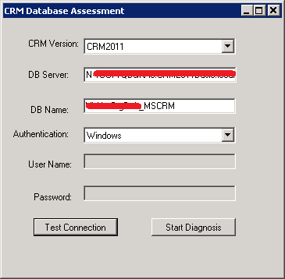

You can either click on Test Connection or Start Diagnosis button

Test Connection will test connection with given DB and on successful connection a message will be shown as below

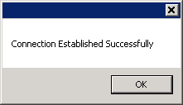

Start Diagnosis will initiate connection and start diagnosis, on successful run a new file will be created named ‘DBAssessmentReport.xml’ and message containing file path will be shown as below.

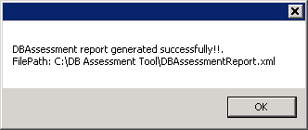

# 

# Appendix

## Keyword Category

|  |  |  |
| --- | --- | --- |
| No | Category | Description |
| 1 | Must | Issues to fix |
| 2 | Should | Recommend to rework |
| 3 | Could | Consider to rework |

Table 4 Keyword Category